Kimberly Mackey

Cit 220

Chapter 10

1. Log in to thompson
2. list all processes with: ps -A
3. Pipe the output of ps -A to grep to see if sshd is running
   1. ps -A | grep sshd
4. **Take a screenshot and paste it into the Word document**

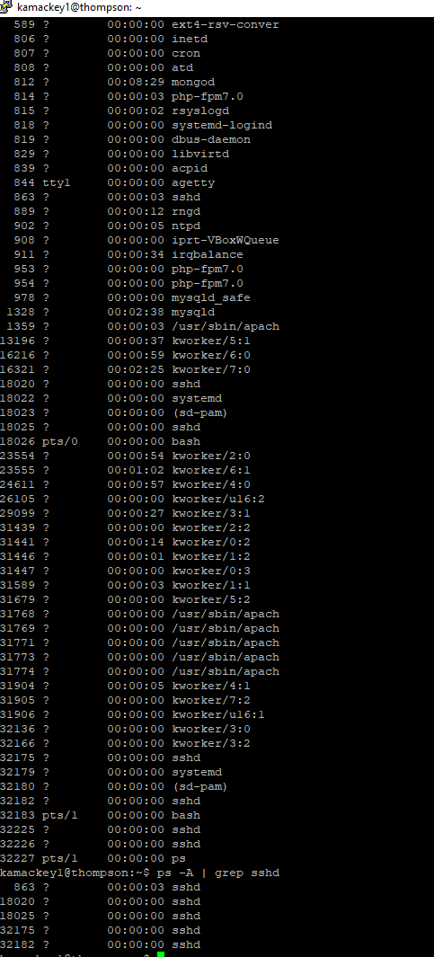

1. From the command prompt open the program 'zork'zork
2. Note that you cannot use the shell because it is being used by zork (but you can play zork).
3. Open another putty window or terminal and make a second connection to thompson.
4. Use ps -U USERNAME u (that's a capital 'U', followed by YOUR username, followed by a lowercase 'u')
5. **Take a screenshot and paste it into the Word document**

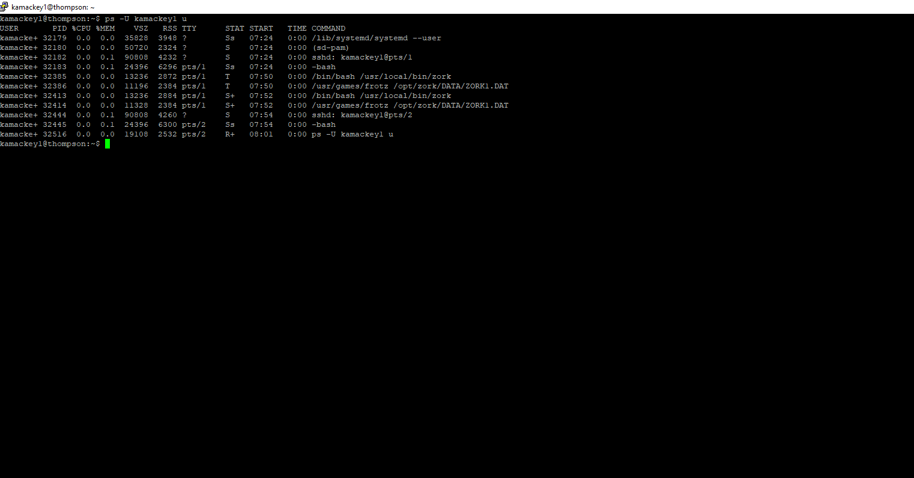

1. Find the process ID for 'zork' (you will actually see two possibilities, either one will work)
2. Use the kill command to kill the zork process by its ID
3. **Take a screenshot and paste it into the Word document**

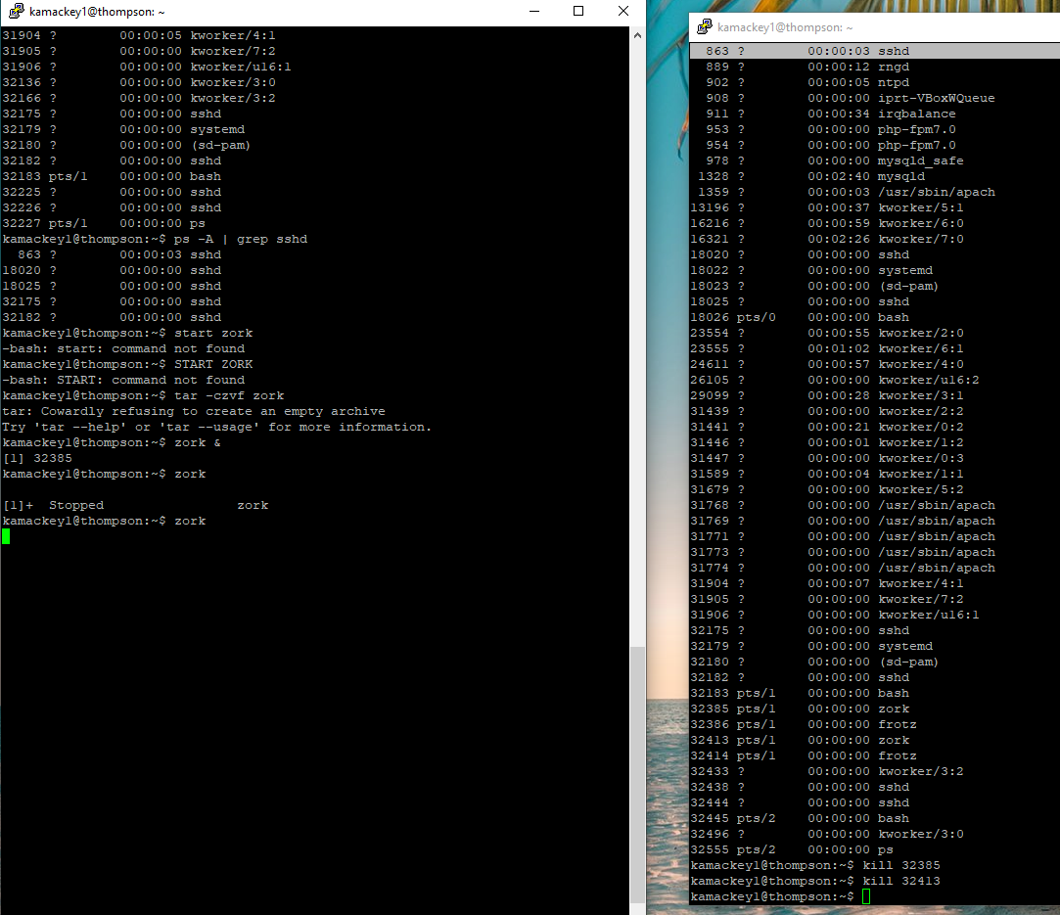

1. Go back to the first Putty/SSH connection and run zork again
2. This time, press Ctrl-z to stop zork.
3. Enter the 'jobs' command
4. **Take a screenshot and paste it into the Word document**

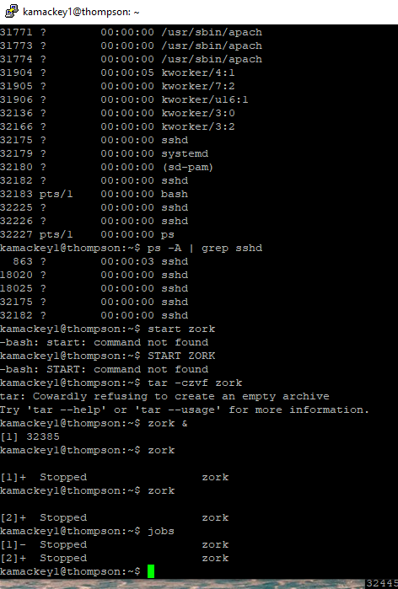

1. Type 'python3' to start a Python programming interpreter
2. Press Ctrl-z to pause Python
3. Enter the 'jobs' command again
4. Use the 'fg' command to bring python3 back into the foreground
5. **Take a screenshot and paste it into a Word document**

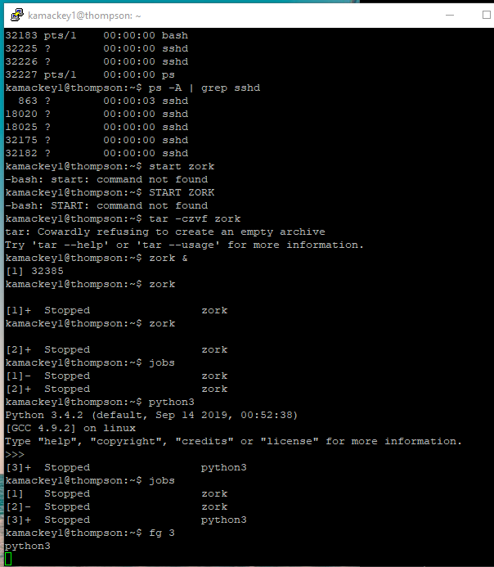

1. Type Ctrl-z again to pause Python
2. Use the 'bg' command to send Python into the background
3. Use 'ps' and 'kill' to kill the Python process
4. **Take a screenshot and paste it into a Word document**

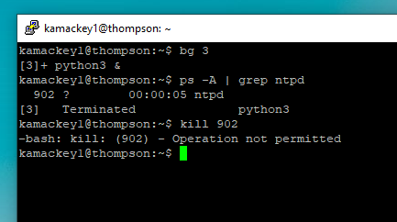

1. Use 'fg' to bring zork back into the foreground.
2. You can play it for a bit if you like. When finished enter 'exit'
3. Submit the Word document to this assignment in Blackboard